Extra-Corporeal Membrane Oxygenation (ECMO): information for baems team
SETTING | Bristol ECMO Service
FOR STAFF | Bristol Ambulance EMS team members driving for the ECMO Service
Introduction
The purpose of this document is to provide some background information about ECMO should you wish to read it. It is not mandatory but may be of interest, particularly if you wish to see a little more of what the Bristol ECMO Service retrieval team that you are working with are doing.

What is ECMO?
Extra-Corporeal Membrane Oxygenation (ECMO) is a technology which allows the addition of oxygen and removal of carbon dioxide by a modified heart-lung machine to support failing lungs. The technology uses two large intravenous cannulae (big drips, usually placed via both femoral veins in the groin) to circulate the blood to the heart-lung machine and back to the patient.
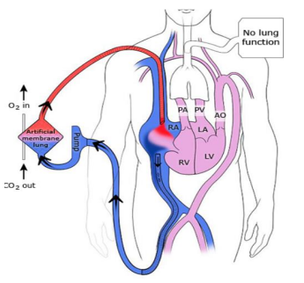

The type of ECMO offered in Bristol is veno-venous ECMO which is used to support failing lungs. Typically, patients will be suffering from a respiratory illness such as influenza infection or a bacterial pneumonia and will already be on a mechanical ventilator in the Intensive Care Unit (ICU). In certain cases, despite the support of a ventilator patients will remain hypoxic (short of oxygen) and the addition of ECMO support may be required in order for them to recover.
The Bristol ECMO team are able to travel to referring hospitals to place patients on ECMO in their local hospital before moving them on Mobile ECMO back to the Bristol Royal Infirmary using a specially equipped ECMO trolley.

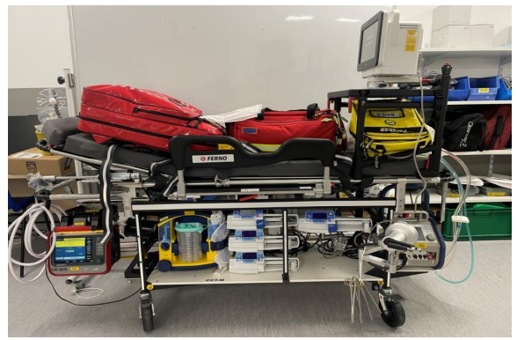

The Bristol ECMO Service
The Bristol ECMO service was commissioned in 2021 to add resilience to the existing national ECMO network and create an ECMO service for the South West Critical Care Network (see map below). The service is based on site at the Bristol Royal Infirmary but consists of staff drawn from all four Intensive Care Units in the two Bristol Trusts (Weston General, North Bristol and the general and cardiac ICU at the BRI).
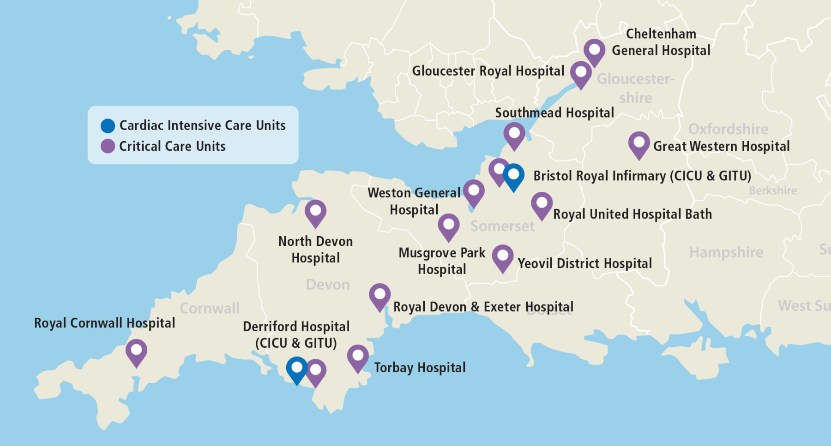

The Bristol ECMO retrieval team will consist of at least three members (there may be more than one member of each staff group):
An ECMO nurse specialist nurse
An ECMO retrieval consultant
A perfusionist (responsible for managing the ECMO circuit).
Occasionally, the Bristol ECMO service team may be asked to provide mutual aid to other ECMO services and attend patients outside the South West. They will inform BAEMS of this at the time of organising vehicles and give you as much information and notice as possible if longer journeys are anticipated.

ECMO Retrieval
Once a decision has been made to assess a patient on site for ECMO support, the Bristol ECMO service will contact Bristol Ambulance EMS to mobilise the ambulance and the rapid response vehicle.
The team are required to leave within an hour of making this decision. Once they arrive at the referring hospital they will assess the patient (usually in ICU) and make a final decision about whether to start ECMO support. If they proceed, the ECMO cannulation will take place in the operating theatre and may take up to 2 hours. The ECMO consultants will place two cannulae (large drips) into the femoral veins and the blood will have oxygen added and carbon dioxide removed by the artificial lung. Once the patient has been placed on ECMO support, they will be packaged on the ECMO retrieval trolley for the return journey to the BRI.
Occasionally, when the BRI is at capacity or for other clinical reasons, an ECMO patient may require transfer beyond Bristol to one of the other ECMO centres in England. The Bristol ECMO team will inform you of this before the in case an additional driver is required.

ECMO duration
After arrival at the BRI, patients will be supported on ECMO until their lungs recover sufficiently to allow support with oxygen or ventilation alone. The average duration of ECMO support is 16-17 days in the UK, meaning that patients spend a lot of time in Intensive Care. At this stage, patients may be suitable to be repatriated to their referring hospital for ongoing care closer to their home and support network.
ECMO is an important life-saving treatment and in the UK, survival rates are around 75%.

Further information
If you have questions, there is usually time to talk to the Bristol ECMO team and they will happily answer them. Please be aware, as in all aspects of critical care transfer work, that the team may be very busy with the critically ill patient.
For additional information the following reading resources may be of interest:
Basic www.elso.org/ecmo
Intermediate Alfred ECMO guideline, ELSO ECMO 101

Document Governance
REFERENCES
RELATED  DOCUMENTS AND PAGES | Bristol ECMO Service SOPs  Bristol ECMO Retrieval Service SOP
AUTHORISING BODY
SAFETY
QUERIES AND CONTACT | Bristol ECMO Team  Retrieve Leadership Team

